Program 10 (CO5)

AIM: Program to implement UI design using manifest code .

<?xml version="1.0" encoding="utf-8"?>

<androidx.constraintlayout.widget.ConstraintLayout xmlns:android="http://schemas.android.com/apk/res/android"

xmlns:app="http://schemas.android.com/apk/res-auto"

xmlns:tools="http://schemas.android.com/tools"

android:layout_width="match_parent"

android:layout_height="match_parent"

android:background="@drawable/b12"

tools:context=".MainActivity">

<EditText

android:id="@+id/editTextTextPersonName2"

android:layout_width="218dp"

android:layout_height="48dp"

android:layout_marginBottom="44dp"

android:drawableLeft="@drawable/ic_baseline_person_outline_24"

android:drawablePadding="10dp"

android:ems="10"

android:hint="username"

android:inputType="textPersonName"

android:textColor="@color/black"

android:textColorHint="@color/black"

app:layout_constraintBottom_toTopOf="@+id/editTextTextPersonName5"

app:layout_constraintEnd_toEndOf="parent"

app:layout_constraintHorizontal_bias="0.517"

app:layout_constraintStart_toStartOf="parent"

app:layout_constraintTop_toTopOf="parent"

app:layout_constraintVertical_bias="1.0" />

<EditText

android:id="@+id/editTextTextPersonName5"

android:layout_width="214dp"

android:layout_height="51dp"

android:layout_marginTop="348dp"

android:drawableLeft="@drawable/ic_baseline_lock_24"

android:drawablePadding="10dp"

android:hint="password"

android:textColor="@color/black"

android:textColorHint="@color/black"

app:layout_constraintEnd_toEndOf="parent"

app:layout_constraintHorizontal_bias="0.507"

app:layout_constraintStart_toStartOf="parent"

app:layout_constraintTop_toTopOf="parent" />

<TextView

android:id="@+id/textView7"

android:layout_width="wrap_content"

android:layout_height="wrap_content"

android:layout_marginTop="20dp"

android:text="forgot password?"

android:textColor="@color/black"

android:textSize="20dp"

app:layout_constraintEnd_toEndOf="parent"

app:layout_constraintHorizontal_bias="0.633"

app:layout_constraintStart_toStartOf="parent"

app:layout_constraintTop_toBottomOf="@+id/editTextTextPersonName5" />

<TextView

android:id="@+id/editTextTextPersonName6"

android:layout_width="wrap_content"

android:layout_height="wrap_content"

android:layout_margin="50dp"

android:layout_marginBottom="36dp"

android:ems="10"

android:gravity="center"

android:inputType="textPersonName"

android:text="Sign in"

android:textColor="@color/black"

android:textSize="28dp"

android:textStyle="bold"

app:layout_constraintBottom_toTopOf="@+id/editTextTextPersonName2"

app:layout_constraintEnd_toEndOf="parent"

app:layout_constraintHorizontal_bias="0.67"

app:layout_constraintStart_toStartOf="parent"

app:layout_constraintTop_toTopOf="parent"

app:layout_constraintVertical_bias="1.0" />

<Button

android:id="@+id/button3"

android:layout_width="wrap_content"

android:layout_height="wrap_content"

android:backgroundTint="#680404"

android:text="SIGN UP"

android:textColor="@color/white"

android:textSize="20dp"

android:textStyle="bold"

app:layout_constraintBottom_toTopOf="@+id/editTextTextPersonName6"

app:layout_constraintEnd_toEndOf="parent"

app:layout_constraintHorizontal_bias="0.993"

app:layout_constraintStart_toStartOf="parent"

app:layout_constraintTop_toTopOf="parent"

app:layout_constraintVertical_bias="0.723" />

<Button

android:id="@+id/button5"

android:layout_width="319dp"

android:layout_height="71dp"

android:layout_marginTop="72dp"

android:backgroundTint="#E91E36"

android:text="Log In"

android:textStyle="bold"

app:layout_constraintEnd_toEndOf="parent"

app:layout_constraintHorizontal_bias="0.532"

app:layout_constraintStart_toStartOf="parent"

app:layout_constraintTop_toBottomOf="@+id/textView7" />

</androidx.constraintlayout.widget.ConstraintLayout>

<?xml version="1.0" encoding="utf-8"?>

<androidx.constraintlayout.widget.ConstraintLayout xmlns:android="http://schemas.android.com/apk/res/android"

xmlns:app="http://schemas.android.com/apk/res-auto"

xmlns:tools="http://schemas.android.com/tools"

android:layout_width="match_parent"

android:layout_height="match_parent"

tools:context=".MainActivity2"

android:background="@drawable/b3">

<TextView

android:id="@+id/textView"

android:layout_width="wrap_content"

android:layout_height="wrap_content"

android:text="Sign up"

android:textColor="@color/black"

android:textSize="28dp"

android:textStyle="bold"

app:layout_constraintBottom_toTopOf="@+id/editTextTextPersonName"

app:layout_constraintEnd_toEndOf="parent"

app:layout_constraintStart_toStartOf="parent"

app:layout_constraintTop_toTopOf="parent"

app:layout_constraintVertical_bias="0.71" />

<EditText

android:id="@+id/editTextTextPersonName"

android:layout_width="wrap_content"

android:layout_height="wrap_content"

android:drawableLeft="@drawable/ic_baseline_person_outline_24"

android:drawablePadding="10dp"

android:ems="10"

android:hint="Name"

android:inputType="textPersonName"

android:textColorHint="@color/black"

app:layout_constraintBottom_toTopOf="@+id/editTextTextPersonName3"

app:layout_constraintEnd_toEndOf="parent"

app:layout_constraintHorizontal_bias="0.497"

app:layout_constraintStart_toStartOf="parent"

app:layout_constraintTop_toTopOf="parent"

app:layout_constraintVertical_bias="0.819" />

<EditText

android:id="@+id/editTextTextPersonName3"

android:layout_width="wrap_content"

android:layout_height="wrap_content"

android:drawableLeft="@drawable/ic_baseline_email_24"

android:drawablePadding="10dp"

android:ems="10"

android:hint="Email"

android:inputType="textPersonName"

android:textColorHint="@color/black"

app:layout_constraintBottom_toTopOf="@+id/editTextTextPersonName4"

app:layout_constraintEnd_toEndOf="parent"

app:layout_constraintHorizontal_bias="0.497"

app:layout_constraintStart_toStartOf="parent"

app:layout_constraintTop_toTopOf="parent"

app:layout_constraintVertical_bias="0.898" />

<EditText

android:id="@+id/editTextTextPersonName4"

android:layout_width="wrap_content"

android:layout_height="wrap_content"

android:drawableLeft="@drawable/ic_baseline_lock_24"

android:drawablePadding="10dp"

android:ems="10"

android:hint="password"

android:inputType="textPersonName"

android:textColorHint="@color/black"

app:layout_constraintBottom_toTopOf="@+id/editTextTextPersonName7"

app:layout_constraintEnd_toEndOf="parent"

app:layout_constraintHorizontal_bias="0.497"

app:layout_constraintStart_toStartOf="parent"

app:layout_constraintTop_toTopOf="parent"

app:layout_constraintVertical_bias="0.908" />

<EditText

android:id="@+id/editTextTextPersonName7"

android:layout_width="wrap_content"

android:layout_height="wrap_content"

android:layout_marginTop="396dp"

android:drawableLeft="@drawable/ic_baseline_lock_24"

android:drawablePadding="10dp"

android:ems="10"

android:hint="Reset password"

android:inputType="textPersonName"

android:textColorHint="@color/black"

app:layout_constraintEnd_toEndOf="parent"

app:layout_constraintHorizontal_bias="0.497"

app:layout_constraintStart_toStartOf="parent"

app:layout_constraintTop_toTopOf="parent" />

<Button

android:id="@+id/button"

android:layout_width="280dp"

android:layout_height="42dp"

android:layout_marginTop="32dp"

android:backgroundTint="#121212"

android:text="sign in"

app:layout_constraintEnd_toEndOf="parent"

app:layout_constraintHorizontal_bias="0.496"

app:layout_constraintStart_toStartOf="parent"

app:layout_constraintTop_toBottomOf="@+id/editTextTextPersonName7" />

<TextView

android:id="@+id/textView2"

android:layout_width="53dp"

android:layout_height="48dp"

android:layout_marginTop="20dp"

android:text="OR"

android:textColor="@color/black"

android:textSize="20dp"

android:textStyle="bold"

app:layout_constraintEnd_toEndOf="parent"

app:layout_constraintStart_toStartOf="parent"

app:layout_constraintTop_toBottomOf="@+id/button" />

<Button

android:id="@+id/button4"

android:layout_width="119dp"

android:layout_height="42dp"

android:backgroundTint="@color/black"

android:text="login"

android:textColor="@color/white"

app:layout_constraintBottom_toBottomOf="parent"

app:layout_constraintEnd_toEndOf="parent"

app:layout_constraintHorizontal_bias="0.458"

app:layout_constraintStart_toStartOf="parent"

app:layout_constraintTop_toBottomOf="@+id/textView2"

app:layout_constraintVertical_bias="0.0" />

</androidx.constraintlayout.widget.ConstraintLayout>

OUTPUT

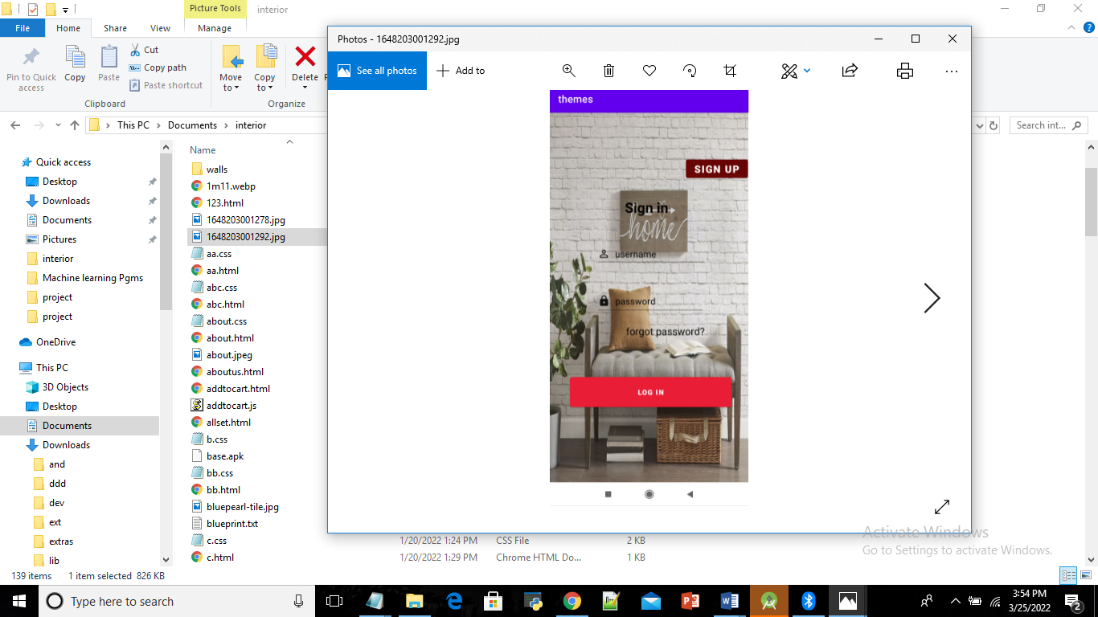

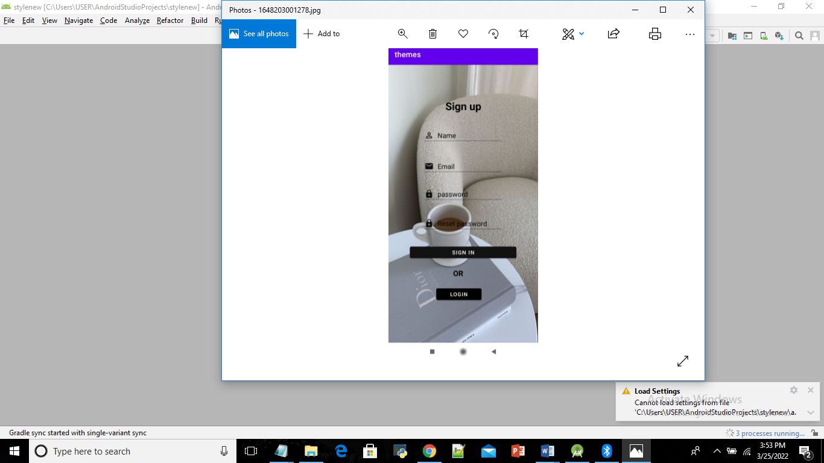

RESULT: Program to implement UI design using manifest code is successfully executed and output verified.